caers: centralized air emissions reporting system

User Manual | 2020
Table of Contents
User Manual | 2020 1
Introduction 3
Oil and Gas Source Registration Information 3
Eligibility 3
Access 4
User: Public 5
User: Company or Consultant 6
Gaining Access to CAERS 6
Workbook Completion 7
Entering Data in the Workbook 7
Included Worksheets 7
Saving the Workbook 12
CAERS Registration Features for Company & Consultant Users 12
Company Information & Authorized users 13
Uploading A Registration Workbook 13
Uploading Supplemental Registration Data 14
View All Registered Sources 15
Enter registration data for Individual Sources 17
Invoices 18
CAERS Oil and Gas Emissions Inventory Submissions 21
Oil and Gas Emissions Inventory Template 21
Oil and Gas Emissions Inventory Workbook Upload 22
Troubleshooting and Contacting UDAQ 23
Suggested Company or Consultant Workflow 23

Introduction
Centralized Air Emissions Reporting System (CAERS) is an online portal and database for oil and gas emissions developed by the Utah Division of Air Quality (UDAQ) and Utah Department of Technology Services (DTS).
The Utah Division of Air Quality (DAQ) seeks to facilitate improved oil and gas emissions inventory tracking and collections, data accuracy, and distribution of emissions data to the public and to the National Emissions Inventory (NEI). The purpose of CAERS is to extend the use of the current oil and gas online system to include, in addition to the existing ability to submit permit applications, the ability to submit a facility registration for all oil and gas facilities regardless of size. Additionally, CAERS will facilitate the ability to seamlessly submit a triennial emissions inventory for oil and gas facilities, including sources that operate under an approval order. The system will be designed to streamline the handling of emissions data by adapting the current set of Python scripts to automate the process of importing the data to a more robust Oracle database. These additions and improvements to the existing system will provide a central location to submit all air quality-based oil and gas data in an efficient and streamlined manner. This central system will facilitate the distribution of summarized emissions data directly to the DAQ webpage for public consumption and export a data file pre- formatted for submittal to the National Emissions Inventory (NEI).
If you have any questions or problems with the CAERS system, please do not hesitate to contact UDAQ for assistance.
ogregistration@utah.gov
801-536-4000
Utah Division of Air Quality
P.O. Box 144820
Salt Lake City, UT 84114-4820

Oil and Gas Source Registration Information
On January 26th, 2018, the Air Quality Board passed Rule R307-505, which establishes requirements for oil and gas sources to register with the Division of Air Quality. Registration retention and management is contained in CAERS. Sources operating under an approval order have been conjoined into CAERS by UDAQ to allow for data management of all oil and gas sources.

Eligibility
The registration requirement applies to new and existing sources involved in oil and natural gas exploration, production, and transmission operations; well production facilities; natural gas compressor stations; natural gas processing plants and commercial oil and gas disposal wells, and evaporation ponds. Sources with an Approval Order are exempt from registration. The flowchart in Figure 1 guides users through various registration eligibility scenarios.
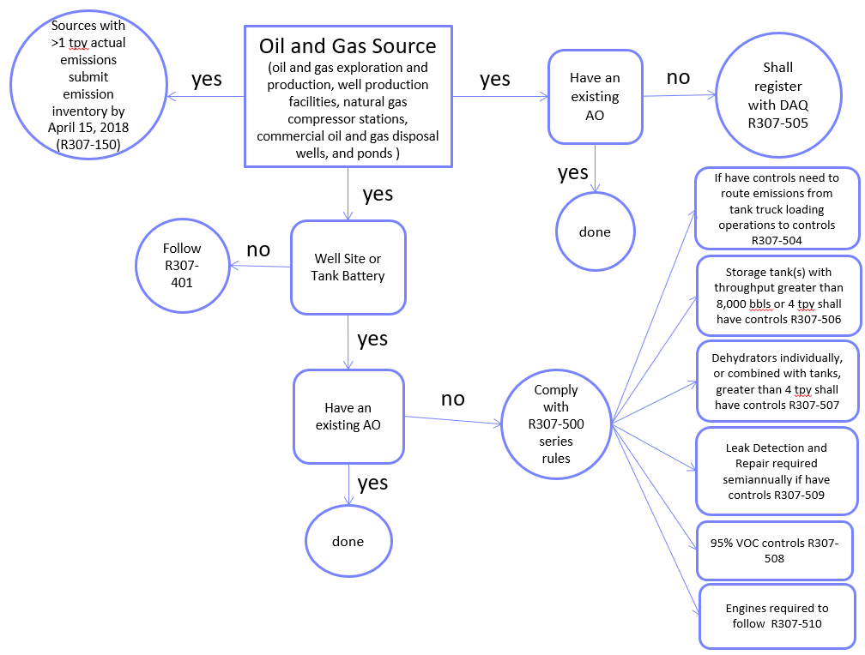
Figure 1: Oil and gas source registration flowchart
Complete rules regarding registration and other R307-500 series rules for oil and gas can be found at: https://rules.utah.gov/publicat/code/r307/r307.htm

Access
CAERS and its associated data are not accessible to the public. In order to access CAERS, users must have an established UMD (Utah Master Directory, also referred to as Utah-ID), previously filed a notarized data submission form with either Utah Division of Oil, Gas, and Mining (UDOGM) or UDAQ, and approval from an administrator or engineer at UDAQ. Each user will be assigned a role within their associated company; users are not able to submit or view outside their company assignment (Consultants – see “Notice to Consultants” at the end of this subsection).
To create a profile, visit http://caers.utah.gov. Alternatively, you can visit https://deq.utah.gov/air-quality/oil-gas-source-registration-air-quality . Click the blue button that says “CAERS” to be directed to the system portal.
Access to CAERS requires a UMD. Users will be directed to the page shown in Figure 2. If a user does not have an active UMD account, click “Create Account” and follow the instructions. Questions regarding the UMD login system should be directed to the Utah Department of Technology Services (DTS). Call the DTS Help Desk at 801-538-5775.
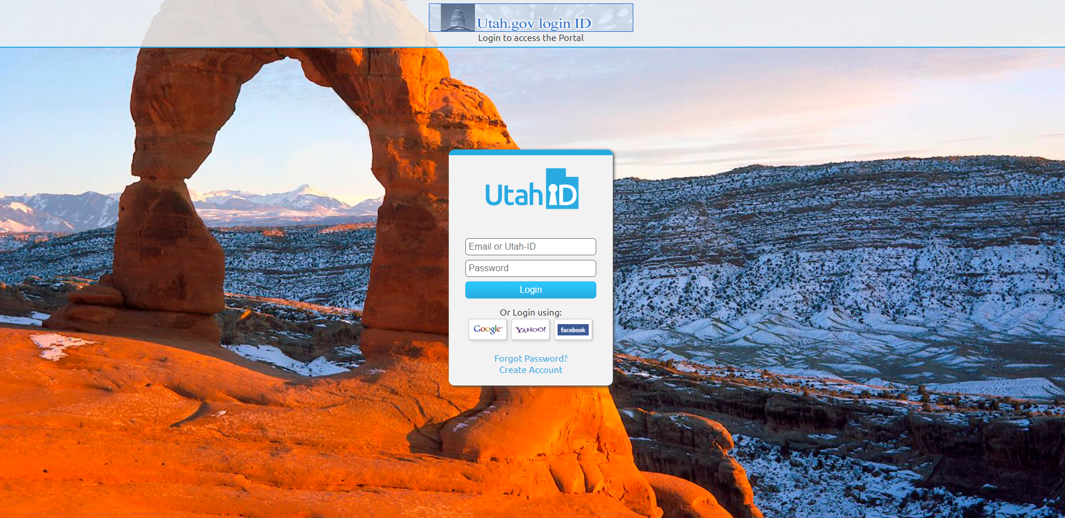
Figure 2: UMD Login screen.

User: Public
All users who attempt to access CAERS with a UMD login will be automatically designated as “Public” users. A public user does not have access to the system. An administrator or engineer will manage public users by changing their imported UMD information profile role from “Public” to any other user type.
After entering one’s UMD for the first time, every user will arrive at the landing page shown in Figure 3.
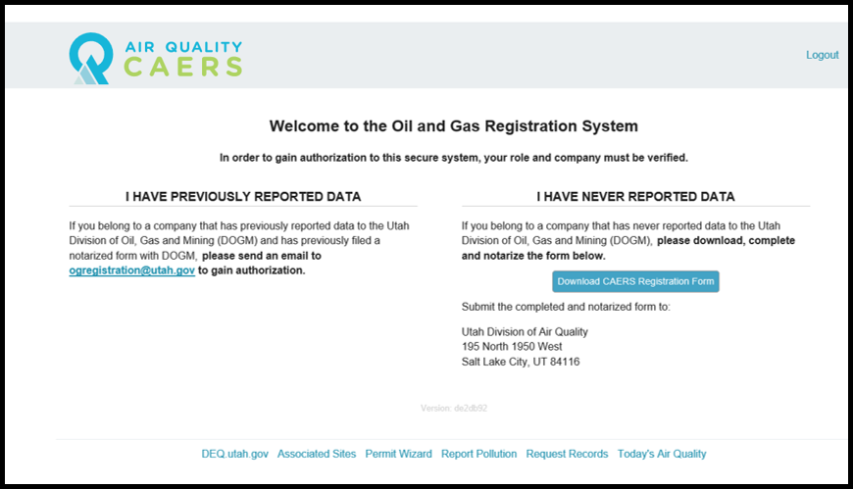
Figure 3: landing page for public users
The text on this landing page only applies to oil and gas operators who will be submitting emissions data to CAERS.

User: Company or Consultant

Gaining Access to CAERS
In order to report data to UDAQ, companies must first gain access to CAERS. There are two pathways though which access may be granted:
- If the company attempting to access CAERS is new to oil and gas data reporting:
  - The User will download the CAERS Registration Form by clicking the large blue button in Figure 3.
  - User will fill out the form and have it notarized by a Notary Public. An updated list of notaries public can be found here: https://secure.utah.gov/notary/search.html
  - Completed and notarized forms should be mailed to the following address:
Utah Division of Air Quality
P.O. Box 144820
Salt Lake City, UT 84114-4820

- If the company attempting to access CAERS has reported any data to UDOGM in the past:
  - UDOGM requires companies to fill out the form exhibited in Figure 4, notarize it, and mail it to the UDOGM offices.
  - If a company has already completed this process with UDOGM, UDAQ will not require the company to file and notarize our data reporting forms. Alternatively, the company must contact UDAQ and provide proof of a previous form transaction with UDOGM.
Figure 4: (Left) UDAQ Registration form to be filled and notarized for access to CAERS; (Right) UDOGM form which, if operators have already filed and notarized with UDOGM, will be accepted in place of the UDAQ Registration form.
Once all forms have been received and approved by UDAQ, the company may provide assigned users access to CAERS. These assigned users may be company employees or consultants, and full access to CAERS by those users will be available via UMD login.
NOTICE TO CONSULTANTS: If a consultant is submitting registration workbooks to CAERS for more than one company, they need to fill out and notarize the form in Figure 4 (Left) for each company by which the consultant is contracted. Additionally, the consultant must contact UDAQ to change their company authorization and association before submitting any data on behalf of a company. Please contact UDAQ (ogregistration@utah.gov, 801-536-4000) for these types of changes. Failing to do so will result in sending new data to an incorrect company – this is very difficult to undo. Please do not hesitate to contact UDAQ!

Workbook Completion

Oil and gas emissions sources are required to register with the State of Utah according to Rule R307-505 as of January 26th, 2018. An owner or operator of an identified oil and gas source must register with the Utah Division of Air Quality (UDAQ) 30 days prior to commencing operation with the information requested in the Registration Workbook. Additionally, an owner or operator shall update the registration information within 30 days of any of the following:
- change to company name,
- removal or addition of control devices and/or equipment,
- or termination of operation.

Registration enables UDAQ to gain greater understanding about the sources that contribute to emissions throughout the state. The Microsoft Excel workbook is designed to streamline the registration process. The workbook was also designed to mimic portions of the 2017 emissions inventory workbook as an effort to save operators time, and therefore some fields may be copied from the 2017 emissions inventory workbook into this Registration workbook.

Additional information and workbook downloads may be accessed at: https://deq.utah.gov/air-quality/oil-gas-source-registration-air-quality

To begin, open the Excel file named “Utah_O&G_Registration_Workbook.” Tabs identifying worksheets that are linked and interactive will be displayed across the bottom of the workbook. Fields shaded in grey should not be modified by the user unless the instructions for that field explicitly state to do so. Fields that are shaded in pink are optional, and are not required to be provided by the user. Worksheets in this workbook include “Certification Statement”, “Operator Info”, “Sources List”, “Associated API #s”, “Installed Equipment”, and “Equipment Specifications.”

Entering Data in the Workbook
Most fields are modifiable and can be filled in by the operator; however, any fields that are static parameters and should not be adjusted are shaded grey. The workbook also includes several drop-down lists which must be selected by the user, and once selected will appear in a blue font. When entering data into the worksheets, be sure to enter the values in correct units that are listed. Units are not modifiable since the calculations in the workbook depend on continuity of units. The current units are standard for calculating emissions at oil & gas operations.

Included Worksheets

Certification Statement
This sheet includes a statement certifying that all information entered into the submitted workbook is true and correct to the best of your knowledge. This certification must be acknowledged in order to complete the registration.

Operator Information
This sheet is for providing basic operator information such as name and address as well as at least one person of contact, and their relevant information, for the operator. Please provide the most recent available information.
- Operator Name – Provide the full name of the operator (text only field).
- Operator Address – Provide the address for the operator, including: Street Address, City (text only), State (text only), and Zip code (numeric only).
- Environmental Contact Name – Provide the name of the main environmental contact for the operator (text only). Note: the Environmental Contact will receive all automatic email notifications from the CAERS system, including registration rejections and invoices.
- Environmental Contact Title – Provide the contact title for the operator’s main contact (text only).
- Environmental Daytime Phone Number – Provide the phone number for the operator’s main contact. Please enter the phone number without any dashes, spaces, or parentheses.
- Environmental Email – Provide the email address for the operator’s main contact.
- Local Contact Name – Provide the name of the local contact for the operator (text only).
- Local Contact Title – Provide the contact title for the operator’s local contact (text only).
- Local Daytime Phone Number – Provide the phone number for the operator’s local contact. Please enter the phone number without any dashes, spaces, or parentheses.
- Local Email – Provide the email address for the operator’s local contact.
- Alternate Contact Name – Optionally provide an alternate contact for the operator (text only).
- Alternate Contact Title – Optionally provide the contact title for the operator’s alternate contact (text only).
- Alternate Phone Number – Optionally provide the phone number for the operator’s alternate contact. Please enter the phone number without any dashes, spaces, or parentheses.
- Alternate Email -- Optionally provide the email address for the operator’s alternate contact.

Sources List
A source is defined in Rule R307-101-2: "Any structure, building, facility, or installation which emits or may emit any air pollutant subject to regulation under the Clean Air Act and which is located on one or more continuous or adjacent properties and which is under the control of the same person or persons under common control. A building, structure, facility, or installation means all of the pollutant-emitting activities which belong to the same industrial grouping. Pollutant-emitting activities shall be considered as part of the same industrial grouping if they belong to the same "Major Group" (i.e. which have the same two-digit code) as described in the Standard Industrial Classification Manual, 1972, as amended by the 1977 Supplement (US Government Printing Office stock numbers 4101-0065 and 003-005-00176-0, respectively).” This includes new and existing sites involved in oil and natural gas exploration, production, and transmission operations; well production facilities; natural gas compressor stations; natural gas processing plants and commercial oil and gas disposal wells, and evaporation ponds. Each of these sources should be listed in a separate row on this sheet.
Note: Sources are referred to as facilities in the 2017 Utah Air Agencies Oil and Gas Emissions Inventory Workbook. Any facilities provided in the emissions inventory should be listed as sources in the registration.
- Source Name – Provide the full name of the source.

- Source Unique ID # - This field is automatically generated by the workbook. This field should not be completed by the operator. Note: This field should be used as the main identifier for each source for the remainder of the workbook.
- Latitude – Provide the latitude of the source including 5 digits after the decimal. Only numeric, decimal values will be accepted. Latitudes are restricted to Utah boundaries, between 36 and 43 degrees N.
- Longitude - Provide the longitude of the source up to 5 digits after the decimal. Only numeric, decimal values will be accepted. Longitudes are restricted to Utah boundaries, between -155 and -109 degrees E.
- County – Provide the county in which the source is located. Use the pull-down menu to select a county.
- Startup Date – Provide the startup date of your source. If your source is new and began operations after January 1st, 2018, list the precise date in MM/DD/YYYY. If you have an existing source that began operations before January 1st, 2018, write in “Before January 1, 2018”.
- Standard Industrial Classification (SIC) code – Provide the SIC code for your source. Only 4 digit, numeric values are accepted.
- General Source Type – Use the pulldown menu to select your general source type. Use the pull-down menu to select the type as listed below.
  - Production Facility
  - Midstream Facility
  - Wastewater Disposal Facility
  - Water Injection Facility
  - Solid Waste Facility
  - Other: Please note type in comments field
- Source Description/Comments – Provide any necessary additional information about your source. If Option F “Other” was selected in General Source Type, this section must be filled out.

Associated API #’s
This sheet is for providing a list of any API #s associated with each source listed in the sources list tab.
- Source Unique ID # - Use the pull-down menu to select the Source Unique ID # that was assigned to the facility in the Sources List tab.
- No Associated APIs or >10 Associated APIs? – Use the pull-down menu to select “Yes” if your source is not associated with any APIs whatsoever, OR if your source has more than 10 associated APIs. If you select “Yes” for a given source, do not fill out the remaining columns in this sheet. Select “No” if your source has at least 1 and up to 10 associated APIs, and enter those corresponding API numbers in the remaining columns.

- API # 1 - #10 – Provide API numbers associated with your source in these columns. Only 10 digit APIs are accepted; do not include well bore values appended to APIs. Make sure the API numbers are saved as numbers, not numbers stored as text (This will prevent successful upload to CAERS).

Installed Equipment
This sheet is for providing details about any equipment installed on each source listed in the sources list tab.
- Source Unique ID # - Use the pull-down menu to select the Source Unique ID # that was assigned to the facility in the Sources List tab.
- Tanks – Use the pull-down menu to select “Yes” if you have tanks installed on your site, or “No” if you do not have tanks installed.

- Dehydrators – Use the pull-down menu to select “Yes” if you have dehydrators installed on your site, or “No” if you do not have dehydrators installed.

- Pneumatic Controllers – Use the pull-down menu to select “Yes” if you have Pneumatic Controllers installed on your site, or “No” if you do not have Pneumatic Controllers installed.

- Engines – Use the pull-down menu to select “Yes” if you have Engines installed on your site, or “No” if you do not have Engines installed.

- Control Device – Use the pull-down menu to select “Yes” if you have any type of control device installed on your site, or “No” if you do not have control devices installed.
  - Combustor
  - VRU
  - Condenser
  - No Control

- Engines: Electric Powered – Use the pull-down menu to select “Yes” if you have electric engines installed on site, or “No” if do you have no engines or only non-electric engines installed on site.

- Control Type – Use the pull-down menu to select what type of controls you have installed. If you selected “No” under Control Device, leave this column as the default “No Control.”

- Percent Control – Enter the level of control (%) provided by your control device. Leave this field as “N/A” if you selected “No Control” in the Control Type column.

Throughput and Emissions
The following three columns are designed to collect recent throughput information, and in some cases, emissions calculations. Only enter information into EITHER column I (oil throughput) OR column J (condensate throughput). Include your most recent annual throughput values in barrels.
In some cases, the green text in column K (Calculated Emissions) will read “Enter Emissions Here & Provide Supplementary Data.” If you see this message, you must enter your calculated potential emissions of volatile organic compounds (VOCs) in column K. Otherwise; calculated emissions information is not required.
- Annual Oil Throughput (BBL) – Provide annual oil throughput in barrels if you operate an oil production facility. Numeric only.

- Annual Condensate Throughput (BBL) - Provide annual condensate throughput in barrels if you operate a gas production facility. Numeric only.

- Calculated Emissions Showing <4 tons VOCs per year – If prompted, provide calculated emissions showing less than 4 tons per year from your source. Please send supplementary data to OGregistration@utah.gov alongside your completed workbook. The supplemental data must include site specific oil or condensate samples, all associated equipment, and calculation assumptions.

- Engines, Electric Powered – Use the pull-down menu to select “Yes” if you have installed electric powered engines. This column defaults to “No” if no engines are installed at the source.

Equipment Specifications
This sheet is for providing a list of any non-electric engines installed at the source. Do not report electric engines. This sheet may be left blank if no engines or only electric engines are installed at the source. Compliance inspectors at the Division of Air Quality will use this information to ensure both Federal and State level compliance.
- Source Unique ID # - Use the pull-down menu to select the Source Unique ID # that was assigned to the facility in the Sources List tab.
- Make – Provide the make of your non-electric engine. Text only.
- Model – Provide the model of your non-electric engine.
- Manufacturer Year (YYYY) – Provide the manufacturer year of your non-electric engine. 4 digit years only.
- Horse Power – Provide the horse power of your non-electric engine.
- Engine Category – Use the pull-down menu to select the category of your non-electric engine as listed below.
  - Natural Gas-Fired Turbine
  - Distillate Oil-Fired Turbine
  - Natural Gas 2-Stroke Lean Burn
  - Natural Gas 4-Stroke Lean Burn
  - Natural Gas 4-Stroke Rich Burn
  - Diesel Industrial Engine <600 hp
  - Gasoline Industrial Engine <250 hp
  - Diesel Large Industrial Engine >600 hp
  - Duel Fuel Large Industrial Engine >600 hp
  - >12/1/2011, 100 ≤ hp < 500
  - >7/1/2010, hp ≥ 500
  - >7/1/2008 to 12/31/2010, 100 ≤ hp < 500
  - >7/1/2007 to 7/30/2010, hp ≥ 500
  - Emergency >1/1/2009, hp > 500
  - Emergency >1/1/2009, 130 ≤ hp < 500
  - Mod/Reconst: >6/12/2006 to <7/1/2007, 25 < hp < 500
  - Mod/Reconst: >6/12/2006 to <7/1/2007, hp ≥ 500
  - >7/1/2008, 25 < hp < 100
  - Emergency > 1/1/2009, 25 < hp < 100
  - Emergency >1/1/2009, 100 ≤ hp < 130
- Fuel combustion type - Use the pull-down menu to select the fuel combustion type of your non-electric engine as listed below.
  - Natural Gas
  - Diesel
  - Propane
  - Field Gas

Saving the Workbook
Once your workbook has been filled out, save the excel file as “Utah_OG_Registration_CompanyName.xlsx” replacing ‘CompanyName’ with your own company’s name.

CAERS Registration Features for Company & Consultant Users
Log into your CAERS account using your UMD username and password. You should arrive at the screen similar to the one exhibited in Figure 5.
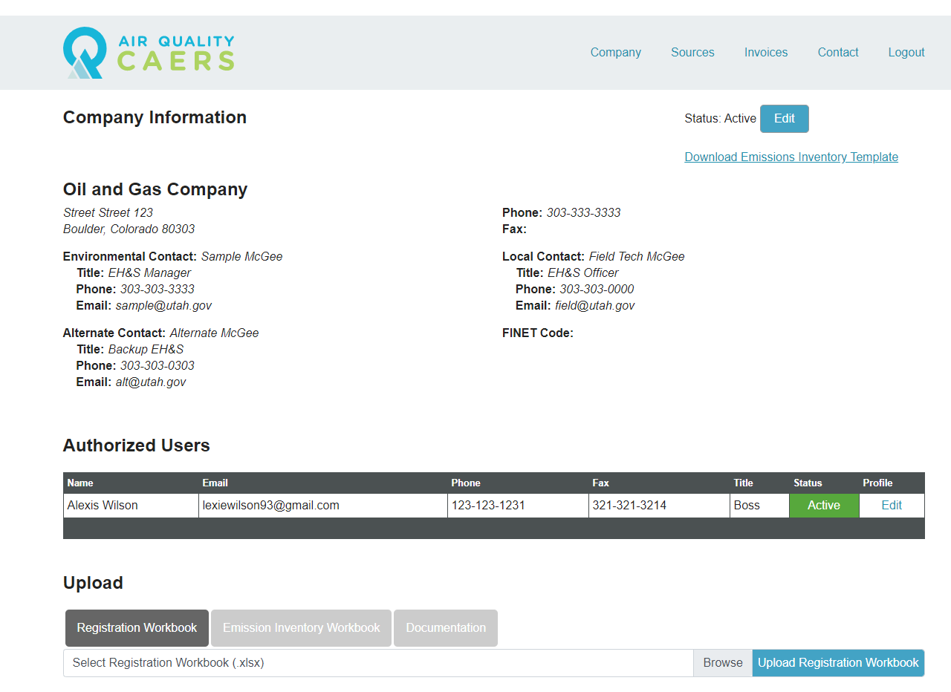
Figure 5: CAERS Company Profile for Company and Consultant user types. This is the user home page.
CAERS Company/Consultant users have access to many data management features, including:
- Ability to see all users authorized to submit data on behalf of the company, and edit company/user contact information*
- Upload oil and gas registration workbooks
- Upload supplemental data in PDF form associated with registration workbooks
- Register individual sources through the browser interface (rather than individual workbook upload)
- Submit oil and gas triennial emissions inventory workbook that is pre-populated with already registered oil and gas sources
- Ability to view and edit all registered sources in CAERS*
- Ability to view outstanding and paid invoices
*These updates to CAERS result in an operator obligation to keep company and contact information up to date, and to keep registration information for all sources up to date by editing source data within CAERS.

Company Information & Authorized users
Company and Consultant users are asked to keep their contact information up to date within CAERS. Contact information is not updated from the Registration Workbook upload, so users are responsible to update information through the CAERS interface directly.
To edit contact information seen on the Company Profile, click the blue “Edit” button in the top right of the page, beneath the main CAERS navigation ribbon (see Figure 5). A pop-up window will appear with several editable fields. After all contact information has been updated, click “Save” to save and close the pop-up window.
Note: Company name changes must still be processed by UDAQ with the submission of an ownership change/company name change notification. Per Rule R307-305, an operator must notify UDAQ within 30 days of any changes. Once the name change has been processed, CAERS administrators will reflect the change in CAERS.
Beneath the contact information text on the Company Profile, there is a table named “Authorized Users.” This table displays the name and contact information of all users that have submitted notarized forms to UDAQ and have therefore been authorized to submit data on behalf of the company. Users cannot be deleted. Clicking “Edit” on the right side of a user’s row in the Authorized Users table will open another pop-up window. Here, user contact information can be updated, or a user status can be switched to “Inactive.” To prevent a user from uploading data on behalf of the company, change their status to “Inactive” and call UDAQ to finish the user removal process and to revoke the user’s authorization form.

Uploading A Registration Workbook
From the CAERS main page – your “Company Profile” – scroll down to the area beneath your contact information. Find three gray boxes, and click the left-most box called “Registration.”

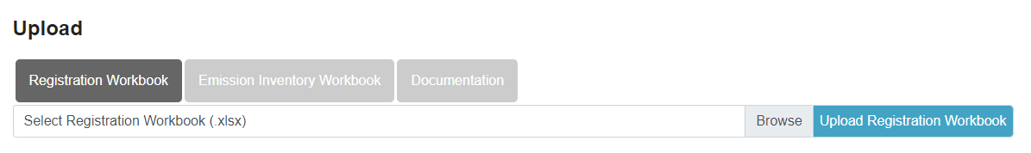
Figure 6: Workbook upload screen
- Click “Browse”
- Locate your completed workbook in your file directory (should have name similar to Utah_O&G_Registration_Workbook_CompanyName.xlsx)
- Click “Upload Workbook”
CAERS will process your workbook data and attempt to enter it into our online database.
Click “Upload” from the top menu bar again to resubmit an updated workbook. You should receive a message like the one in Figure 7. Navigate back to the company profile by clicking “Back to Company Detail” below the Submission ID, or use the main CAERS ribbon.
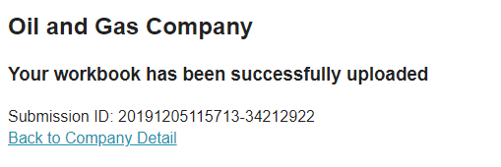
Figure 7: Successful upload message
If there are any errors in uploading the workbook, CAERS will redirect to an errors report, which can be printed. CAERS will not upload any part of a workbook that contains errors. All errors must be fixed before any data will be entered to the system. Most common errors are caused by small structural adjustments to the registration workbook prior to upload. Please sure to preserve the workbook’s original formatting and do not enter data outside the spaces made available in the workbook to avoid these errors.

Uploading Supplemental Registration Data
You may be prompted to submit information regarding calculated emissions for your particular source (see section Installed Equipment on page 10). Submission of supplemental data is required if any given source’s throughput is greater than 8,000 bbls of oil or 2,000 bbls of condensate annually, but the source’s VOC emissions are less than 4 tons per year. If this is the case, submit the following documentation alongside your completed workbook:
- Site specific sampling data (e.g. composition data, API gravity, GOR, RVP, etc.)
- Emissions calculations using direct site-specific sampling data and any software program or calculation methodology in use by industry that is based on AP-42 Chapter 7.
Documentation of this type may be uploaded through CAERS. Navigate to your company profile by clicking on “Company” on the top CAERS ribbon. Scroll down to the upload bar in the center of the web page and click the right-most gray box labeled “Documentation”, as in Figure 8: Documentation upload bar.
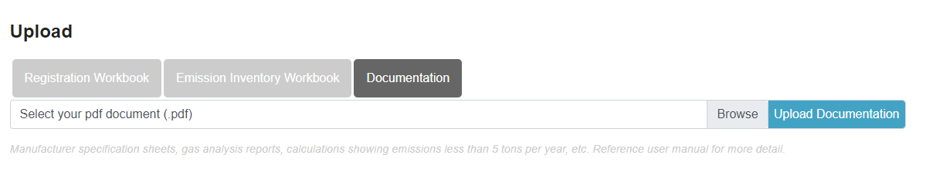
Figure 8: Documentation upload bar.
Click “Browse” to open your file directory and navigate to the file you would like to upload. If documentation is specific to a source, please include the source name in the name of the file prior to upload. CAERS only accepts PDF documents through the upload bar. If you cannot convert your supplementary materials to pdf to be uploaded directly to CAERS, please email them to OGregistration@utah.gov.
Successfully uploaded documents will appear below the upload bar in the “Documents” table. You can view your documents by clicking “View” on the table. The “Delete” button is disabled for Company and Consultant users. If documentation was uploaded in error or has been updated, please contact UDAQ. See section Troubleshooting and Contacting UDAQ on page 23.

View All Registered Sources
Company and Consultant users can now view and edit registration data after they have been uploaded to CAERS. Access the Source Management page by clicking “Sources” on the main CAERS ribbon (see Figure 9).
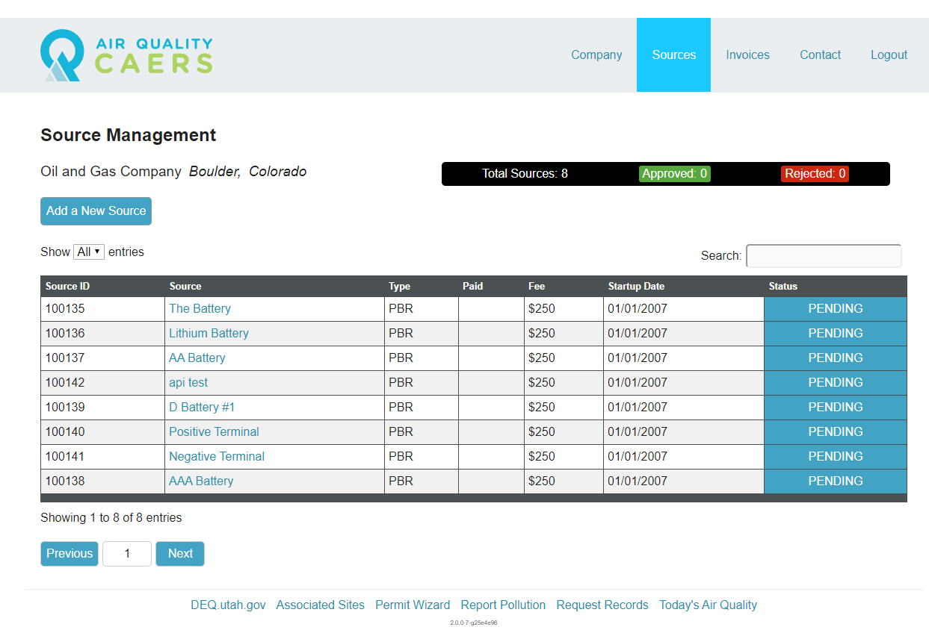
Figure 9: Source Management
Each source that was entered in the Registration Workbook now appears in the Source Management table associated with a unique source ID. Use this source ID to reference your source when troubleshooting issues with UDAQ. The table will expand to show all registered sources on one page by default. Faster page load times can be achieved by using the pull-down menu above the left corner of the table to display fewer entries. All columns in the table are filterable by using the search bar above the right corner of the table. All columns may be sorted in ascending or descending order by double-clicking on the column header.
All sources are listed as “Pending” immediately after upload; source status will change to “Approved” or “Rejected” after a UDAQ engineer reviews your registration submission. Your submission may be rejected if it is found to be outside State of Utah Air Quality jurisdiction, or if other corrections are needed. If this is the case, the “Environmental Contact” listed on the company’s CAERS profile will receive a notification of the rejection and the reviewing engineer will follow up with further instructions via email.
Clicking on the Source name (blue hyperlink within the Source Management table) will take you to the “Source Profile (see Figure 10). All registration data from the registration workbook for a single source can be found be found on that source’s Source Profile. Company and Consultant users may edit the source details embedding in text at the top of the Source Profile by clicking the blue “Edit” button near the top right of the page. A pop-up window will appear, allowing users to change information about the source. Hit “Save” in the pop-up window to save your changes to the source profile.
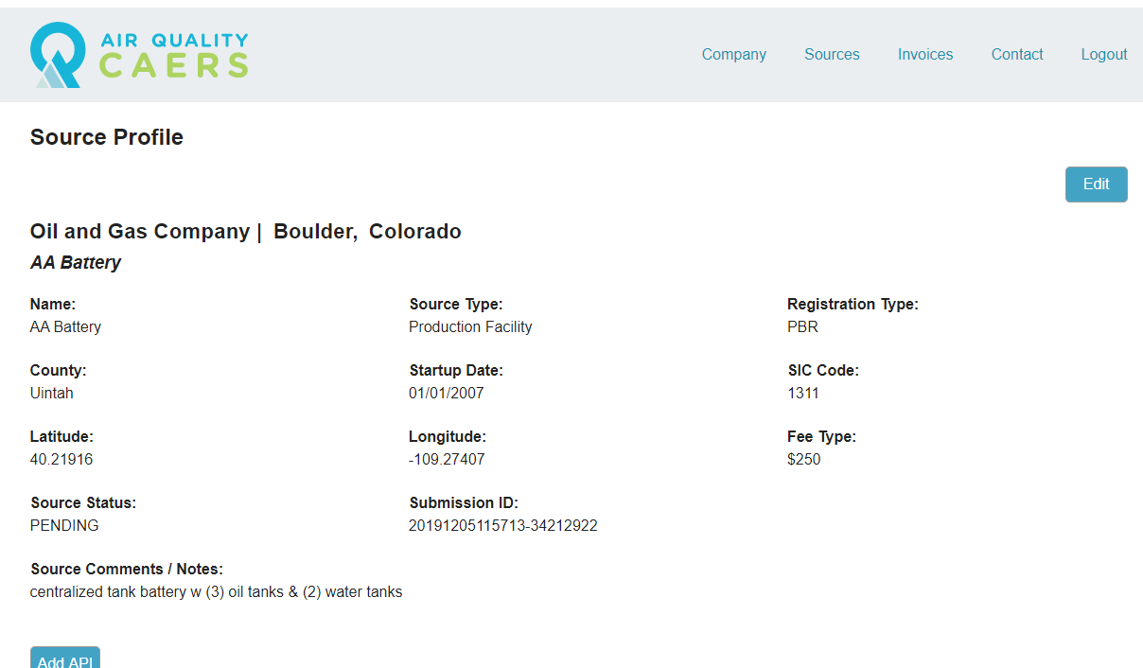
Figure 10: Source Profile page (upper half)
Scrolling down on the Source Profile page leads the user to several tables containing the remaining registration data for that source (see Figure 11).
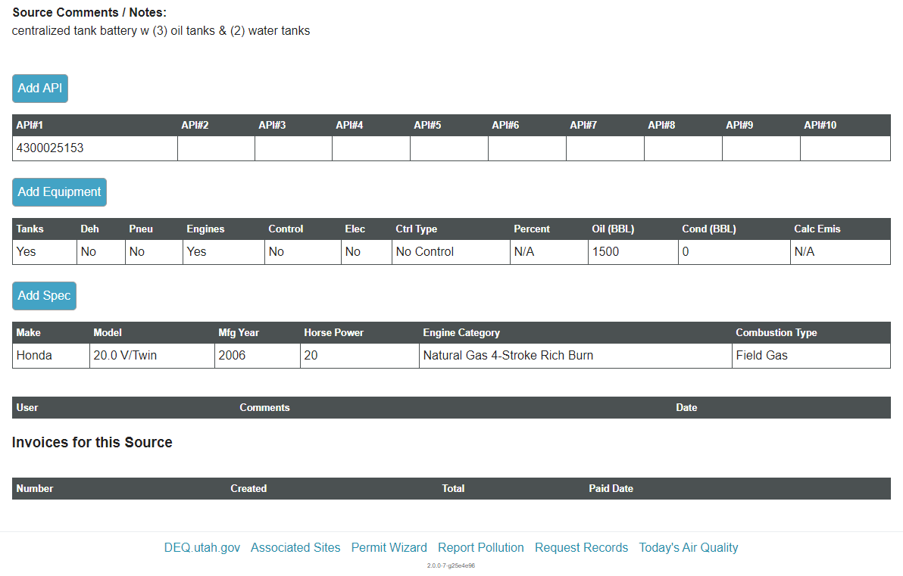
Figure 11: Source Profile page (lower half)
The tables will be pre-populated with data from the registration workbook sheets. If any of the APIs, equipment, or engine specifications change for the source, these tables need to be updated as soon as possible. Clicking on the field in the table will open a pop-up window, allowing Company and Consultant users to edit values.
Note: Editing values in an already-approved registration will automatically post a notification to the reviewing engineer in the “Comments” section of the Source Profile, AND change the status of the registration to “Pending.” A reviewing engineer will review the changes made and re-evaluate the source status. Other comments left by the reviewing engineer throughout the review process can be viewed by Company and Consultant users in this “Comments” section (beneath the Engine Specifications table). However, Company and Consultant users cannot leave their own custom comments here, so any necessary correspondence with the reviewing engineer should be conducted via email or phone.
Note: Sources will be considered out of compliance with Rule R307-505-3 if their registration is not updated to reflect the following changes within 30 days of the change being made:
- Changes to a company name,
- Removal or addition of control devices,
- Termination of operations

Enter registration data for Individual Sources
Registration data can now be submitted directly inside CAERS, rather than uploading a registration workbook to CAERS. UDAQ only recommends using this feature only if Company or Consultant users intend to register an individual site, because traditional workbook upload is capable of uploading multiple sites at once.
To register an individual site within CAERS, Click the blue “Add a New Source” button below your company name on the Source Management page (see Figure 9). A pop-up window will appear requesting registration information for your individual source. The “Source Status”, “Registration Type”, and “Fee Type” are grayed out and can only be edited by the reviewing engineer. Once the remaining blanks have been filled, press “Save.” The pop-up window will close and you’ll be returned to the Source Management page.
Important next step: After adding a new source, you MUST locate the source you just added in the Source Management table and click on the source name to get to the Source Profile page. Notice that the Source Profile tables for your new source are blank. In order for your new source registration to be processed, the Source Profile tables must be filled out in CAERS. When adding data to these tables for a new source, the blue “Add API”, “Add Equipment”, and “Add Spec” buttons will need to be clicked (see Figure 12).
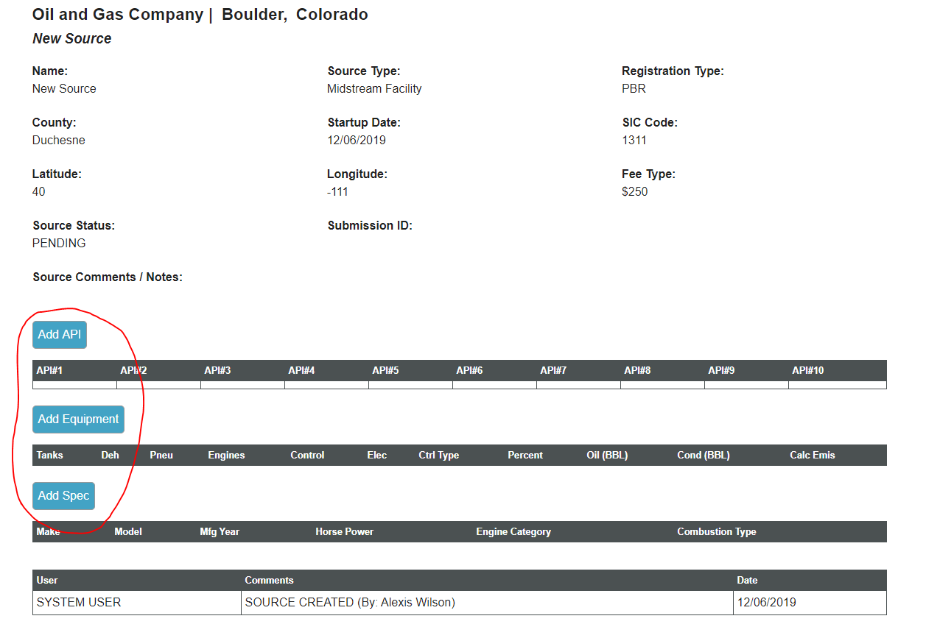
Figure 12: New source registration added from within CAERS. “Add” buttons (circled in red) must be clicked and remaining registration data added in order for new source registration to be considered

Invoices
After registration submissions are reviewed by UDAQ, source status will change from “Pending” to “Approved” (see Figure 13). The reviewing engineer will generate an invoice containing all the approved sources and their associated filing fees. The invoice is automatically emailed to the Environmental Contact of the Company (see Figure 18). Every billed source name, source ID, registration fee associated with each source, and the total amount due to UDAQ will be printed on the invoice. Each invoice also includes a unique invoice ID beginning with the letters “OG” followed by four digits.
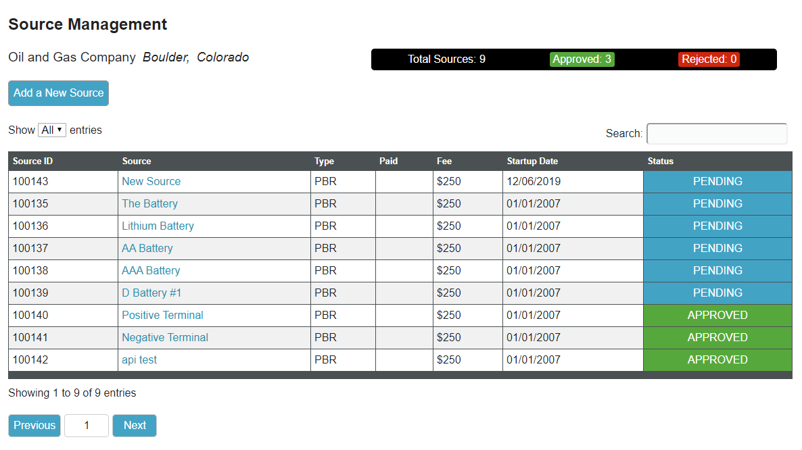
Figure 13: Company source management page, showing some “Approved” sources
After the invoice is created by the reviewing engineer, the invoice will appear on the “Invoices Management” page (see Figure 14). Clicking “Invoices” on the main ribbon will show all invoices sent to the company, and the associated invoice status (see Figure 15). The invoices table shows a maximum of 10 invoices by default, but the pull-down menu above the table on the left side will expand the table.
Figure 14: Invoice Management page for Company & Consultant users
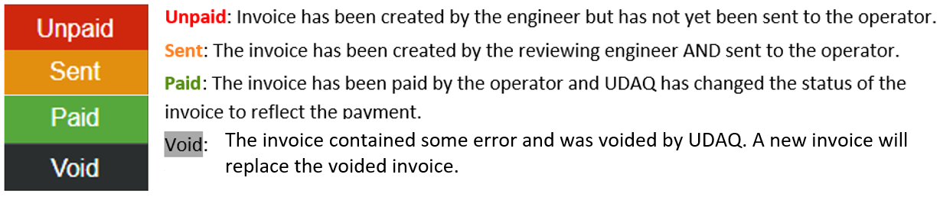
Figure 15: Invoice status key
In the “Invoice” column on the Invoice Management page, clicking “View” will lead to the Invoice Details page (see Figure 16). Here, users can see all the sources included on the particular invoice and the fee associated with those sources. A PDF copy of the invoice (see Figure 17) can be downloaded by clicking the blue “Print Invoice” button in the top right of the screen.
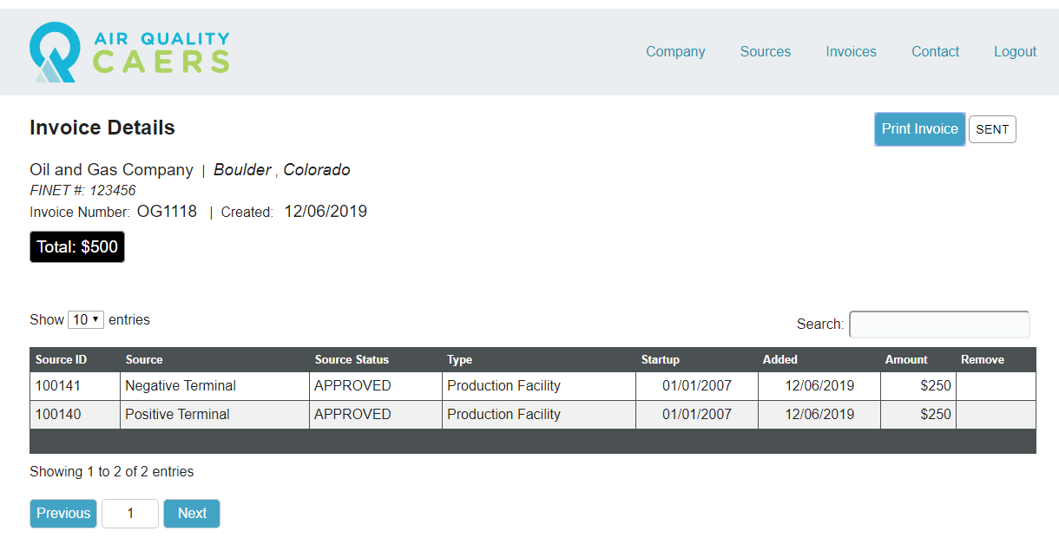
Figure 16: Invoice Details page
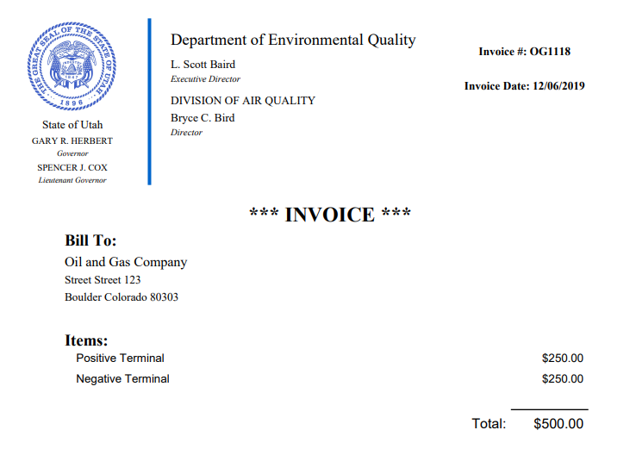
Figure 17: PDF invoice sample

Invoice Email Notifications & Payment Deadlines
The PDF copy of the invoice will be automatically emailed to the Environmental Contact of the company as soon as the reviewing engineer sends it (see Figure 18).
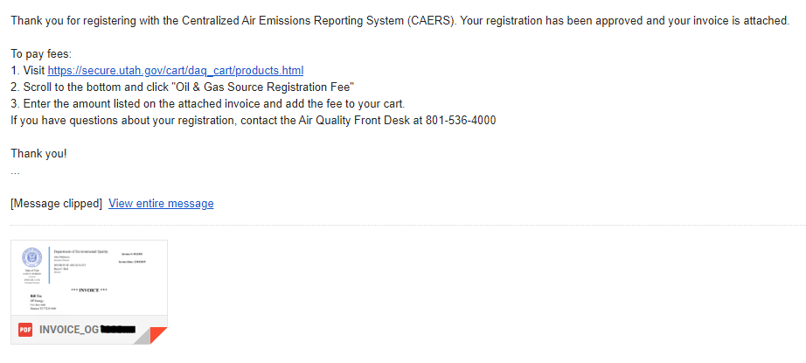
Figure 18: Initial invoice email notification, sent to Environmental Contact
Once an invoice is received by the operator, fees may be paid to UDAQ. Payment instructions will be included in the initial invoice email, but are also included below.
Initial invoice notification:
Thank you for registering with the Centralized Air Emissions Reporting System (CAERS). Your registration has been approved and your invoice is attached.
To pay fees:
1. Visit https://secure.utah.gov/cart/daq_cart/products.html
2. Scroll to the bottom and click "Oil & Gas Source Registration Fee"
3. Enter the amount listed on the attached invoice and add the fee to your cart.
If you have questions about your registration, contact the Air Quality Front Desk at 801-536-4000
Note: Operators have 30 days after the invoice is sent to pay their registration fees. After 45 days, a letter will be sent to the operator notifying them to pay their fees (see quoted text below for the 45 day notification letter). After 60 days, a final notification will be sent to the environmental contact (see second quoted text below), and the unpaid ticket will be sent to the Utah Office of State Debt collection.
45 day notification:
To Whom It May Concern:
Utah Division of Air Quality has registered your source(s) in the Centralized Air Emissions Reporting System (CAERS) in accordance with UAC Rule 307-505. UDAQ is authorized to charge a fee for this work. This fee is determined based on your source’s throughput and/or estimated emissions. If you were previously issued an AO, revoked the AO, and registered your source in CAERS, all registration fees are waived and you may disregard the remainder of this email.
This is a courtesy letter asking for prompt payment of the attached invoice.
Failure to respond to our collection efforts leaves us with no alternative other than to refer your account for collection. State Law, Chapter 63A-8 and legislative intent allow all collection costs to be charged to the debtor, and added to the balance owed including penalty, interest, collection, and legal fees. State law also allows the State to attach your state tax refunds and vendor payments and apply them against the debt owed (called “administrative offset”).
Currently, the attached invoice is now past due. Please pay in full within 15 days of the date of this letter to avoid further action. If payment has been sent please disregard this letter.
Sincerely,
Teri Weiss
Financial Analyst II
(801) 536 - 4183
60 day notification: Invoice OG____ is overdue and has not been paid within the 60 day payment period.

CAERS Oil and Gas Emissions Inventory Submissions
CAERS includes mechanisms for Company and Consultant users to submit their triennial emissions inventory data to UDAQ.

Oil and Gas Emissions Inventory Template
The 2020 Oil and Gas Emissions Inventory workbook must be downloaded directly from CAERS, and CAERS will automatically partially populate the workbook with the currently registered sources in CAERS. For this reason, please ensure that all of your registration and company data are completely correct and up to date within CAERS BEFORE downloading the emissions inventory workbook template. Data will update in the database as soon as changes are saved by the user.
To download the template, click on the “Company” button on the main CAERS ribbon to arrive at the “Company Profile”. Click the blue hyperlink that says “Download Emissions Inventory Template” underneath the blue “Edit” button in the top right corner of the Company Profile (see Figure 19). This download may take a few minutes because CAERS is pasting each registered source into the Oil and Gas Emissions Inventory workbook template.
Figure 19: The Oil and gas emissions inventory workbook can be downloaded from the “Company Profile” page by clicking on the “Download Emissions Inventory Template” link underneath the blue “Edit” button in the top right corner.
A green bar will appear that says “Processing”, but the bar will fade over time. Please be patient during this download and do not refresh the web browser page. When the download is complete, an Excel file will appear in your computer’s “Downloads” directory with the name “EI_workbook_####.xlsx” The four digits in the name of the Excel template are part of the CAERS template generation system and do not otherwise apply to your workbook template. Company and Consultant users may re-name their inventory submission workbooks as they are completed and re-uploaded to CAERS.
Note: Instructions for filling out the Oil and Gas Emissions Inventory Workbook are external to this manual. Please visit https://deq.utah.gov/air-quality/oil-gas-statewide-emissions-inventory-program and click “[YEAR] Oil & Gas Emissions Inventory Workbook Instructions” for the workbook user manual.
Note: The 2020 Oil and Gas Emissions Inventory Workbook is different than the 2017 workbook. Company or Consultant users MUST use CAERS to download the 2020 template and fill out the workbook completely. Each registered source that is pre-populated in the workbook keeps a behind-the-scenes unique identifier that CAERS uses to connect sources between the oil and gas registration database and the triennial oil and gas emissions inventory database. It is imperative that the inventory workbook template is downloaded from the company’s CAERS profile prior to uploading that completed workbook back to CAERS.

Oil and Gas Emissions Inventory Workbook Upload
After the 2020 oil and gas emissions inventory workbook is completed, save final copy of the workbook under the naming scheme “Utah_OG_Inventory_CompanyName.xlsx”, replacing ‘CompanyName’ with your own company’s name.
On the “Company Profile,” navigate to the center of the page and find the Upload bar that has been previously used in the registration process. Select the center gray button that says “Emission Inventory Workbook” (see Figure 20). Click the lighter gray “Browse” button to open your computer’s file directory, navigate to the place where the emissions inventory workbook was saved, and select it. Finally, use the pull-down menu below the upload bar to select the reporting year for which you are uploading inventory data. In this case, select “2020.” Now click the blue button that says “Upload EI Workbook.”
Figure 20: Emissions Inventory Upload bar
Unlike the registration workbook, the emissions inventory is not automatically validated by CAERS, so this upload will not produce an error report. A UDAQ scientist will use internal scripts and manual review to examine your oil and gas emissions inventory workbook submission for completion or errors. UDAQ will contact the environmental contact in CAERS with any questions or suggestions regarding the submission. Once a final version of your emissions inventory workbook is agreed upon, UDAQ will upload the workbook to our database for submission to the National Emissions Inventory (NEI).

Troubleshooting and Contacting UDAQ
If you run into any issues while uploading your workbook, click the “Contact” button on the menu bar at the top of CAERS. Here, you may complete a contact form to send your questions or concerns to UDAQ. Phone numbers and emails for contacting UDAQ directly are also available here.

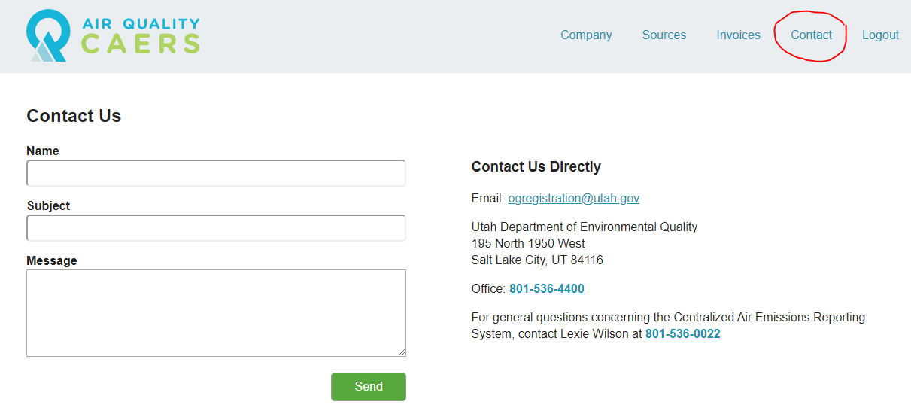
Figure 21: Contact form in CAERS
Please use the above contact information for everything related to CAERS, including any errors associated with invoices. For issues with payments specifically, please contact Teri Weiss, Financial Analyst II, at (801) 536 – 4183.

Suggested Company or Consultant Workflow
- Watch the CAERS training tutorial at https://deq.utah.gov/air-quality/oil-gas-source-registration-air-quality
- Set up your CAERS user account
- If you already have a user account, log in and review your existing data. Check with UDAQ if any data are incorrect, and make any edits necessary.
- For new users, download the registration workbook template from the UDAQ website and fill it out will all sites to be registered. Upload your workbook and wait for UDAQ to review.
- Receive an invoice for newly registered sources and pay invoice within 45 days of receipt.
- Continuously check CAERS data and update as-needed.
- Contact UDAQ with any questions!

